1. **Setting up the project to help us demonstrations throughout the rest of the course**. 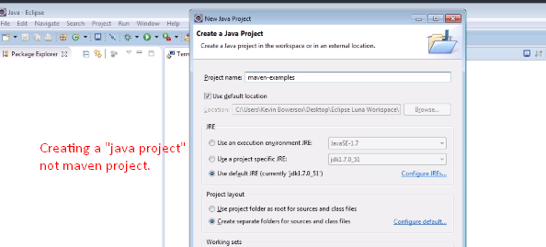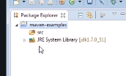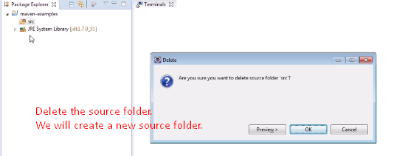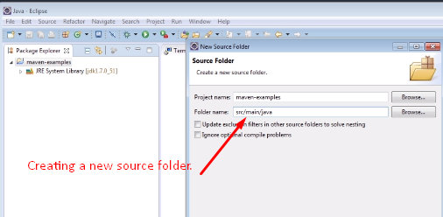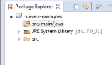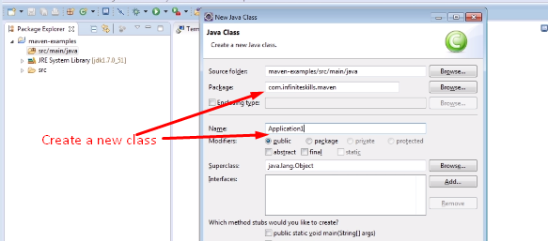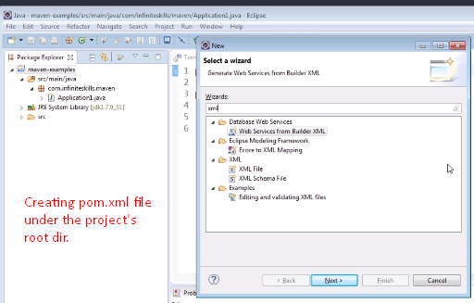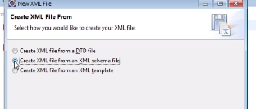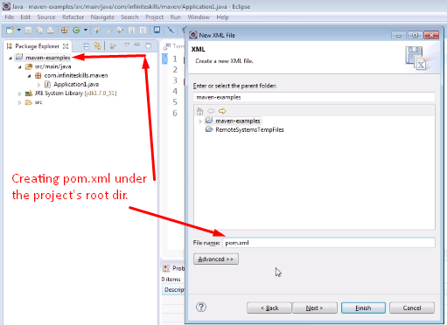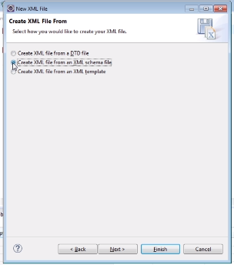We’re going to specify xsd ( XML Schema Definition) file which would define the structure of the XML document we’re going to write. 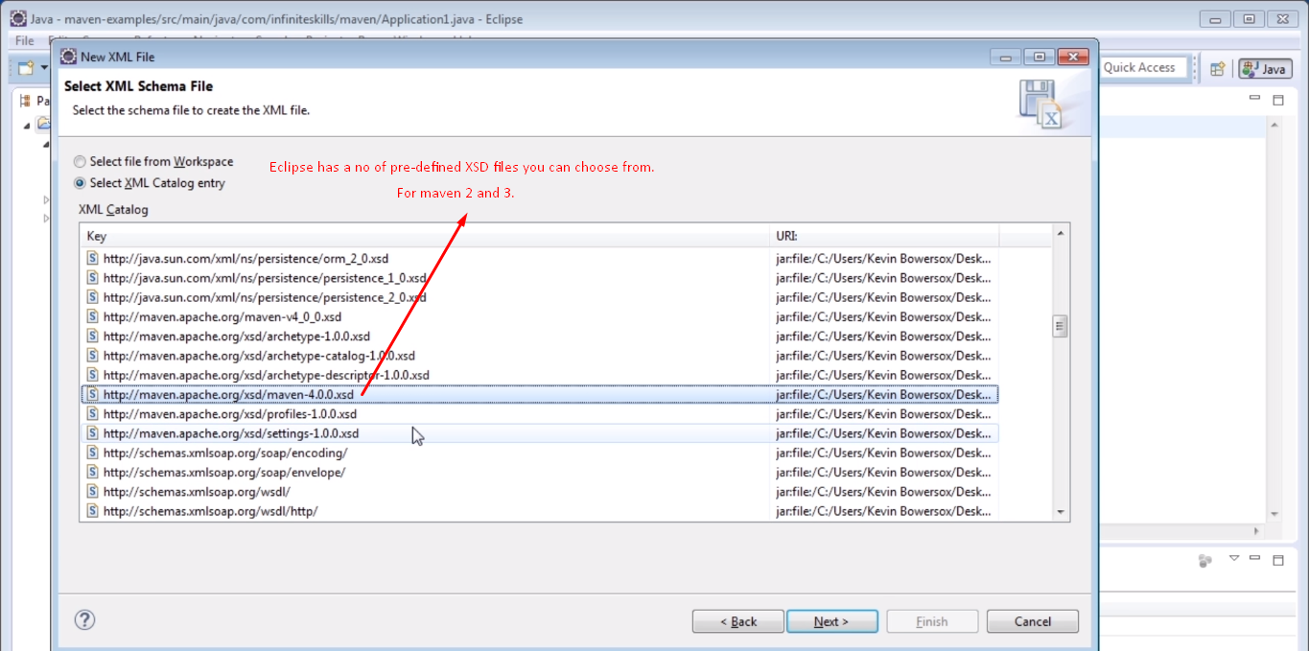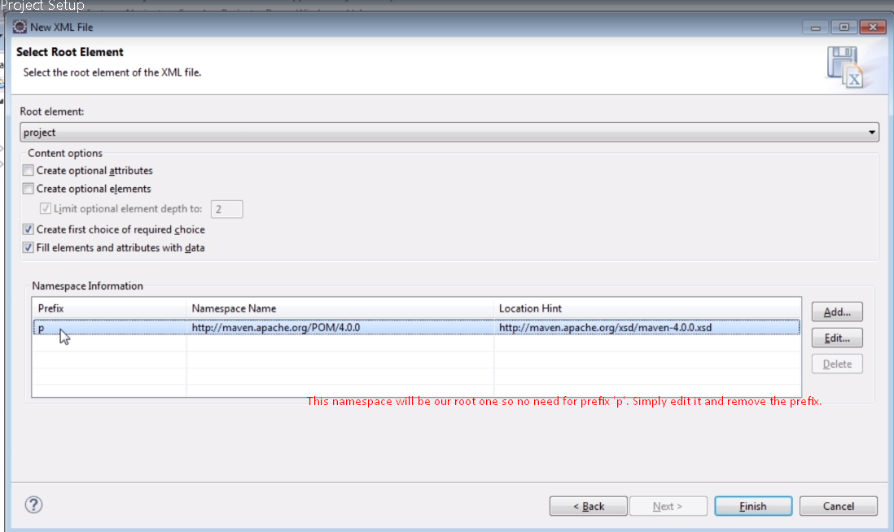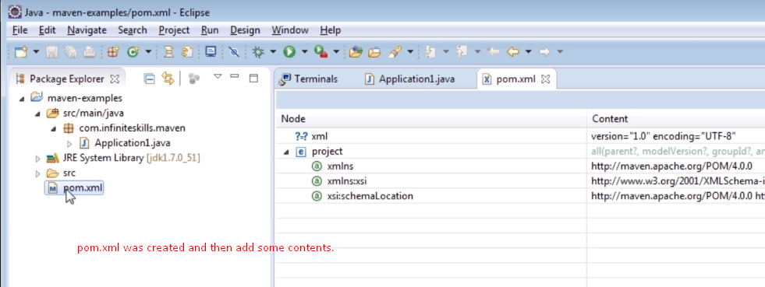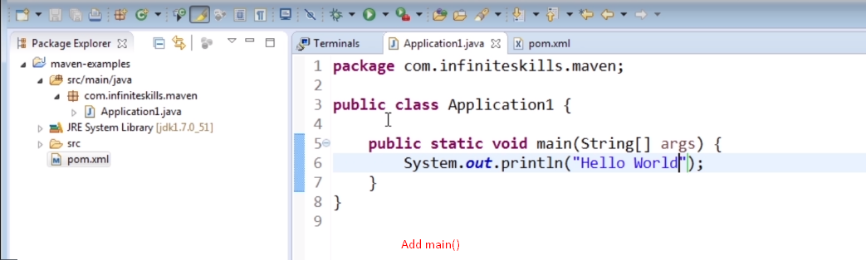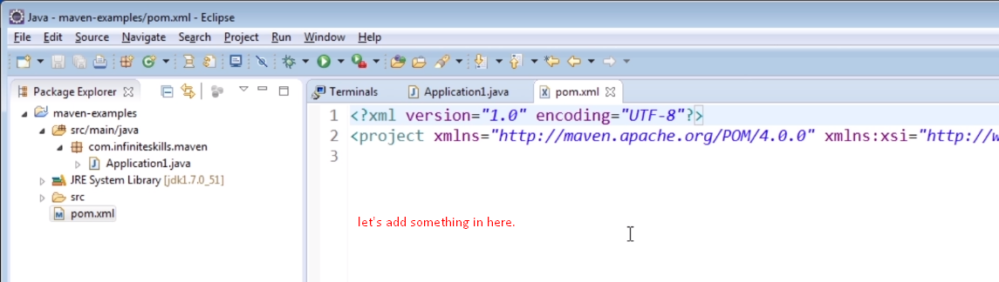
2. **<modelVersion>:** For maven 2 and 3, it is 4.0.0. Must be added for every pom.xml file.
3. Then there are 3 other tags which must be included in every pom.xml file. **These 4 tags are the only required tags**.
4. **<artifactId>**
5. **<groupId>**
6. **<version>**  
   **NOTE**: Dot is used in groupId whereas that conversion is discouraged when defining the artifactId. 